# Problem Description

The aim is to apply a fog-like effect to a scene. A naïve solution is to apply depth-based attenuation on the color of pixels depending on their depth in a scene. However, this only allows for fog of a uniform density, and does not at all represent the complexity of real-life fog with its non-uniform density and noise.

# Problem Solution

In order to more accurately portray and visualize the effect of fog on a scene, the author of the paper proposed the idea of volumetric fog, “a novel, real-time, analytical model for calculating various atmospheric phenomena”. This volumetric fog pipeline is implemented with 3D textures and compute shaders, and is separated into three passes:

* Density Pass
* In-scattering Pass
* Accumulation / Raymarching Pass

Before further explanation, all 3D textures used in this proposal represent the camera frustum. The proposal suggested using exponential depth distribution for dividing the frustum into layers for increased detail in front of the camera. However, I could not get any good results from using exponential depth distribution in my own implementation, so I will only be using linear depth distribution.

# Implementation of Proposal

## Density Pass

The density pass gives as output a 3D texture with a single 16-bit float channel. Since we are using compute shaders, we need a way to get the UVW coordinate corresponding to the texel that each thread will be assigned, like so:



For each texel in this texture, its UVW coordinate is transformed into the respective position in world space.



Then, we use each position in world space as an input of a function that will return to us the density corresponding to that position in world space. This is a completely artist-driven step since this can contain a lot of parameters, such as height-based density attenuation, noise detail and miscellaneous modifications.

Next, we take the resulting density at that position and multiply it by the thickness of the current layer. We do this because the amount of light that will be scattered or absorbed in the in-scattering step will depend on the thickness of the current layer. Finally, we store the result at its corresponding UVW coordinate in the output texture.

## In-scattering Pass

Just like the density pass, we will be assigning a compute thread to each texel in the input and output 3D textures. For the in-scattering pass, we will have a 4 channel RGBA 16-bit float 3D texture that is of the same resolution as the density pass output texture. We first compute the position of texel in world space using the same method. We must also obtain these values as follows:



These values are used to compute the in-scattering contribution of all light sources that interact with the camera frustum:



Note that in my implementation, I only calculated the in-scattering contribution of direct sunlight and did not compute either the ambient or point light source contributions for the sake of simplification. Here all uniform variables are denoted with the prefix “u_”.

For computing the sun light radiance at a given world position, I sampled the shadow map for a shadow factor between 0 and 1, which is multiplied by the sun’s radiance value to get the final perceived radiance.. The anisotropic phase function is mathematically the same as the one described by the proposal.

The final value is stored into the output 4-channel texture in the same way as the density pass.

## Accumulation / Raymarching Pass

For this pass, we create a texture identical to the one found in the in-scattering pass. However, rather than assigning a compute thread for each texel in the texture, we instead create a 2D group of compute threads that covers a single layer of the 3D texture. We then iterate this group forward from front to back (i.e. from the front of the camera frustum to the back of the camera frustum). The values of each layer of the texture are accumulated such that all texel in each subsequent layer contains greater in-scattered light values and a transmittance value.

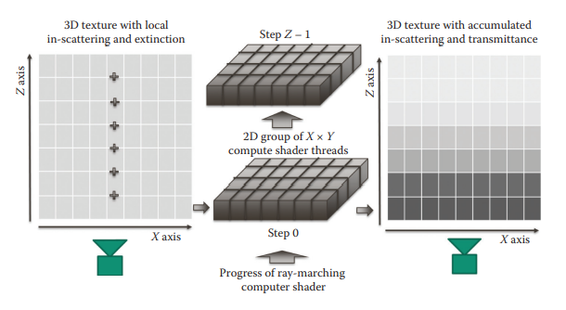

Figure : 2D group of compute threads traversing the 3D textures from front-to-back and accumulating values.



The methods that are used here perform the same function as those presented in the original paper.

## Applying Fog Effect to Shaded Pixels

The last and simplest step is to apply the fog effect to the shaded scene. This involves two things:

* Getting the RGB color of each pixel,
* Getting the UV of each pixel, and
* Getting the depth in view space of each pixel.

The final two are required in order to compute the UVW coordinate in the space of the fog accumulation texture, which we do by transforming our computed eye-space texel position to NDC space and normalizing to UVW space. The fragment shader code is as follows:



Where the volumetric fog sampler is the accumulated 3D texture, and the normalized fog depth is the linearized depth value of the scene.

# Demo Screenshots

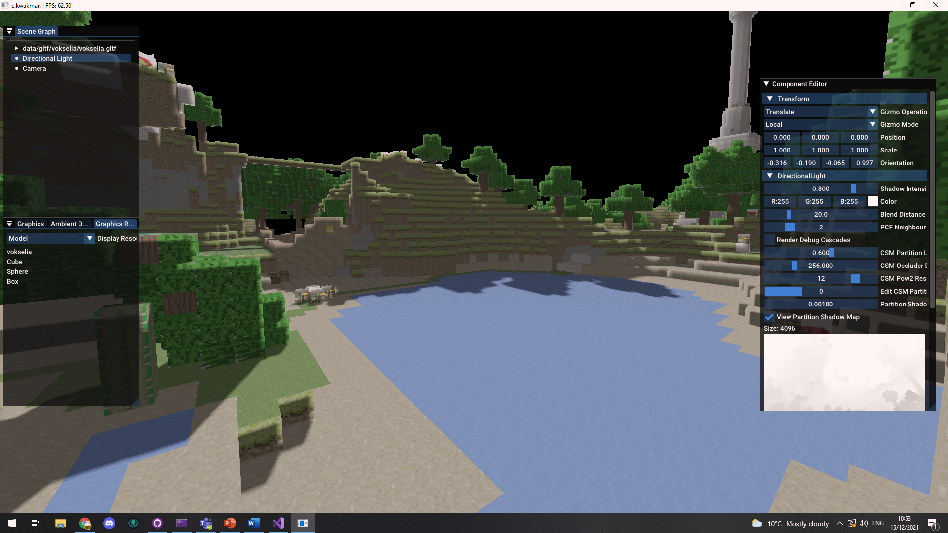

Figure : Default scene, no fog

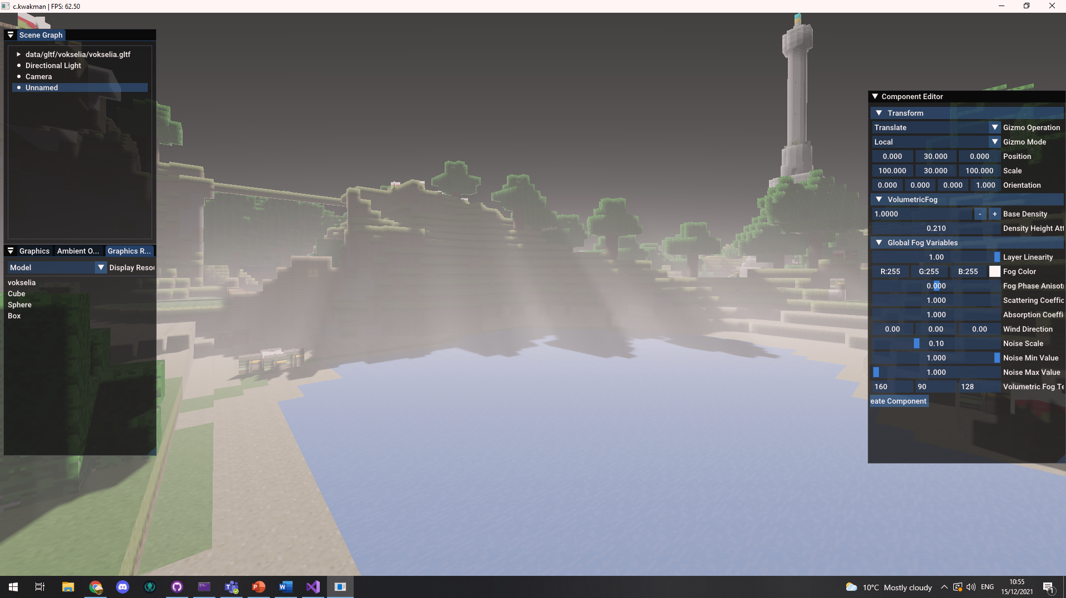

Figure : Uniform fog density, mostly replicable by naïve depth-based fog implementation. Notice, however, that an effect similar to god rays has been created due to the way light interacts with the fog.

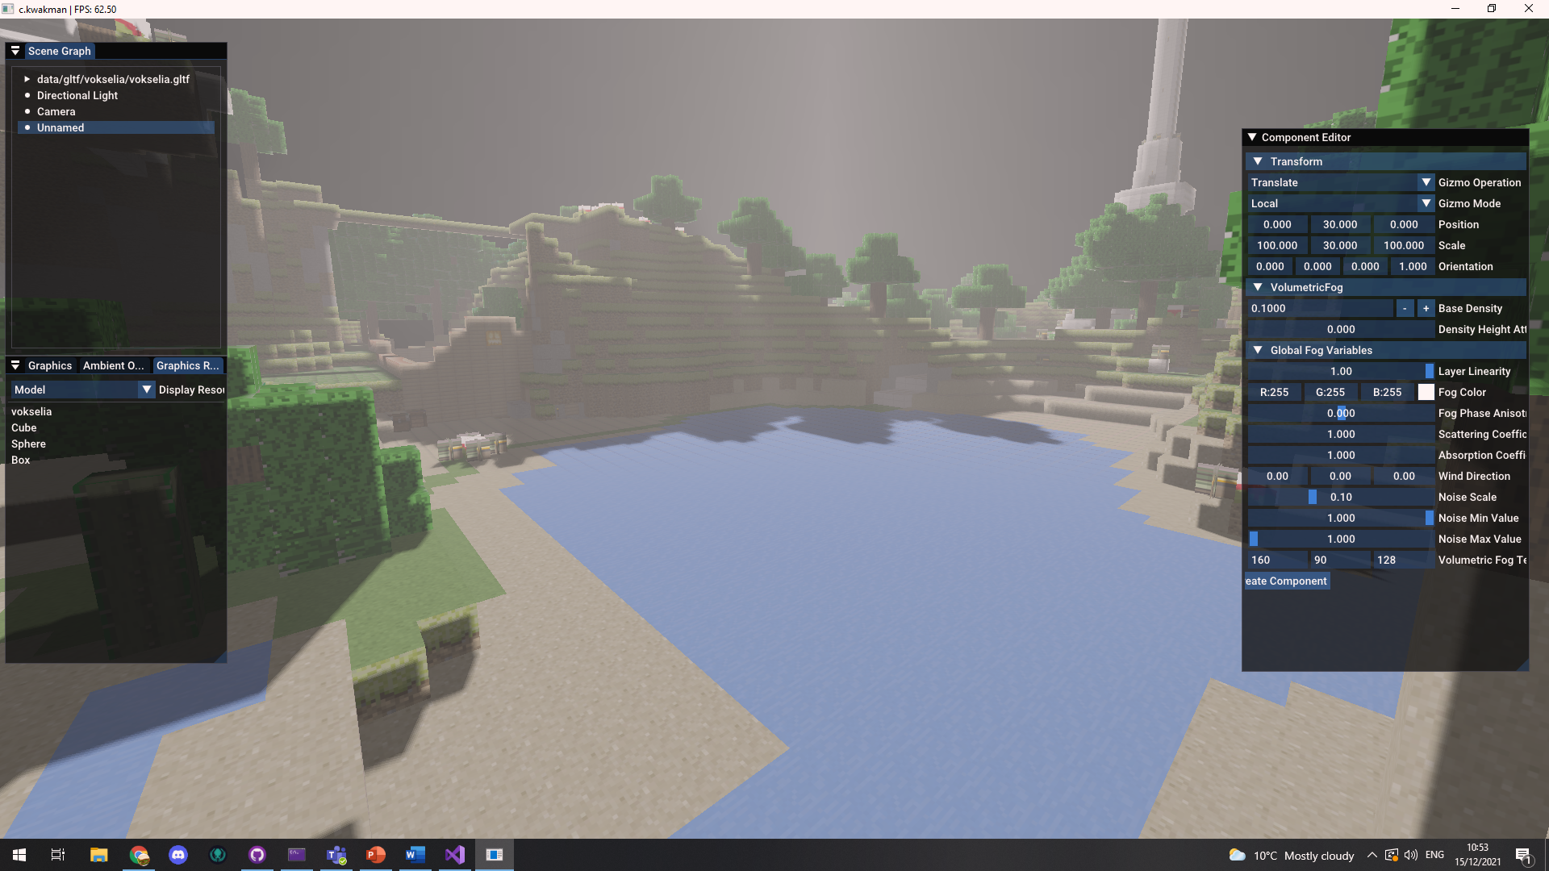

Figure : Height-based attenuation. Density of fog is greater near floor as fog particles tends to be heavier than air

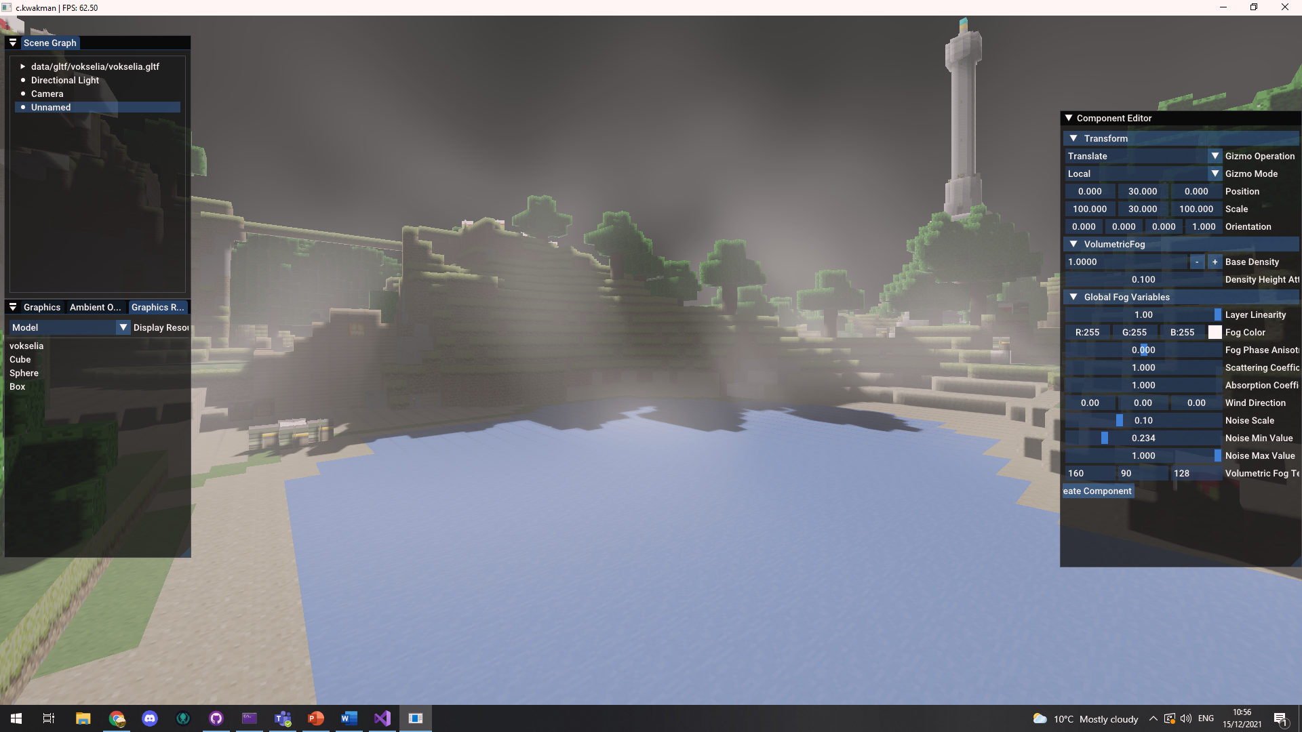

Figure : Use of perlin noise to add detail to fog

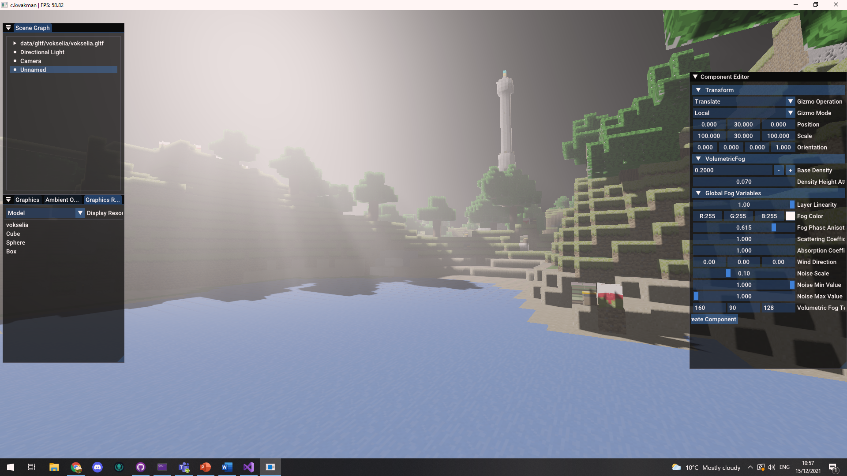

Figure : Increased phase anisotropy of fog to increase in-scattering of fog in direction of light source.

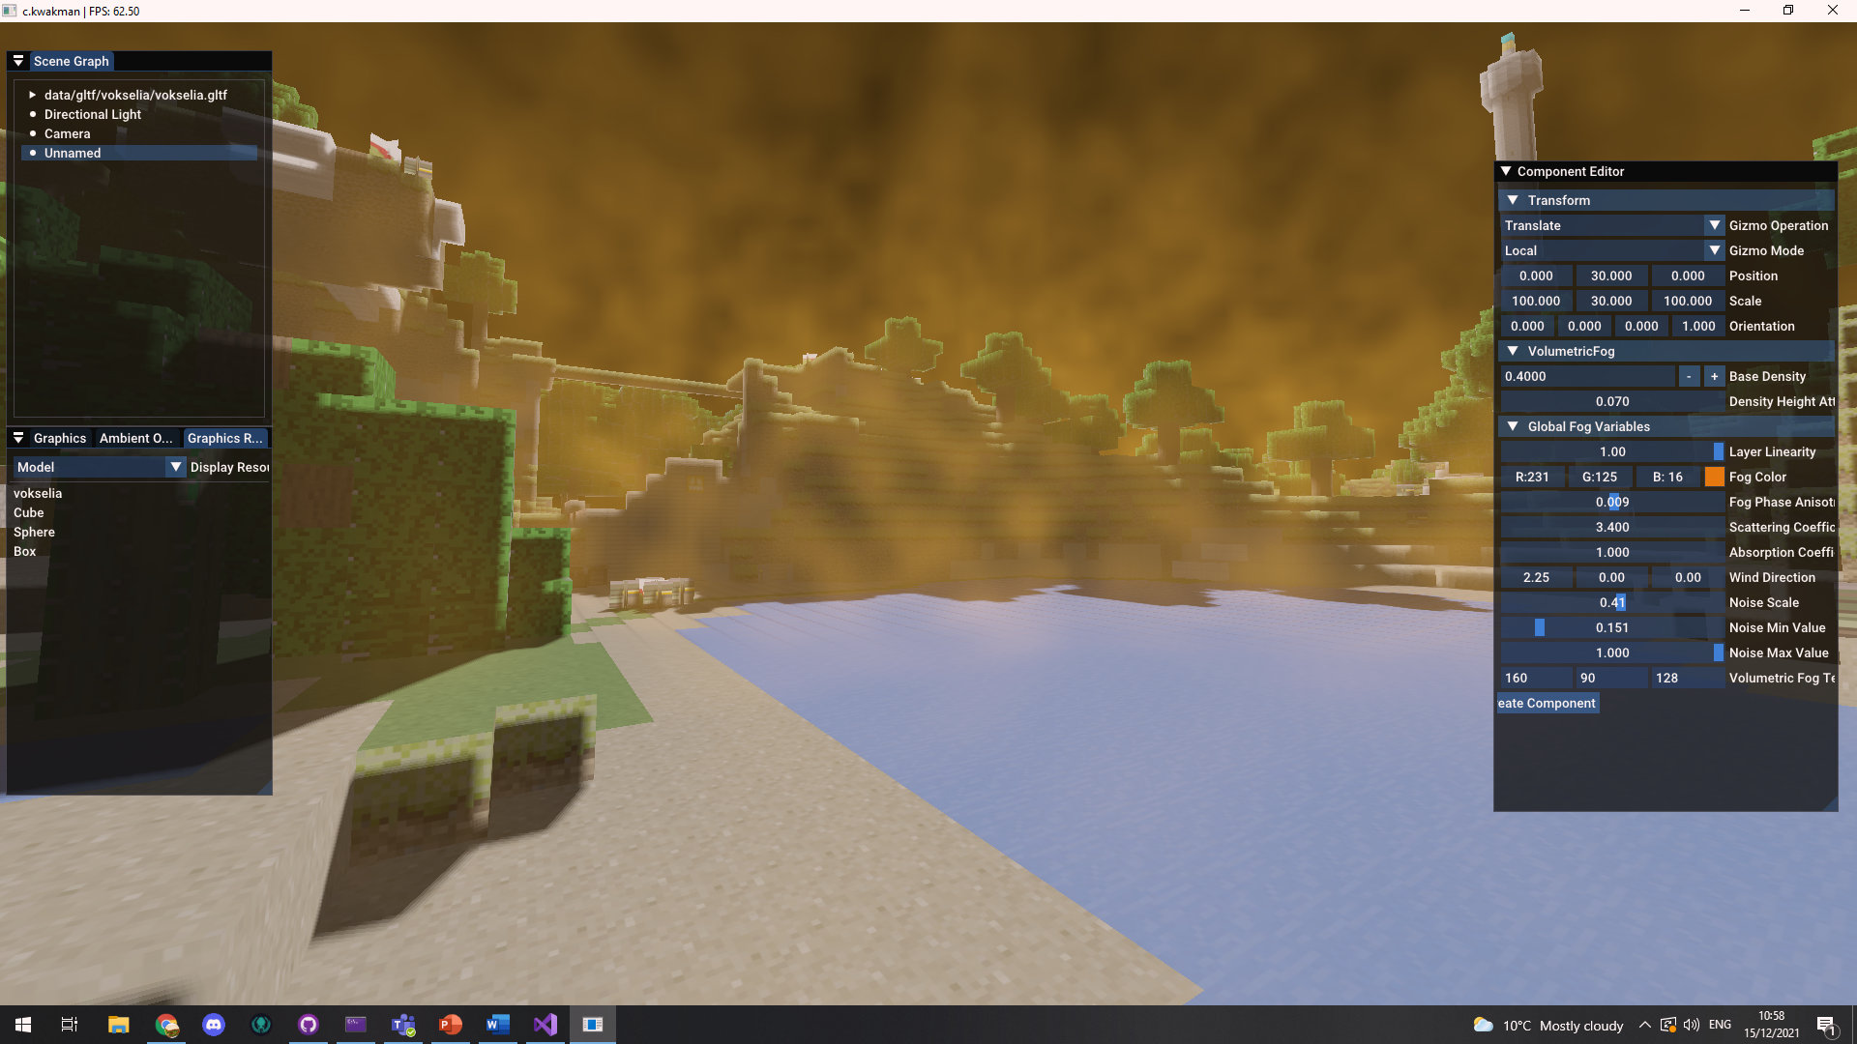

Figure : Simple use of volumetric fog to create basic atmospheric sandstorm effect.

# Demo Usage

The scene controls are identical to those of the normal CS562 assignments.

The demo will load a default scene (“data/scenes/sceneVolumetricFog.json”) which will contain the Vokselia model, a directional light source and a volumetric fog entity. For optimal usage, you should only try to rotate the directional light entity and edit the light color through its components. As for the fog entity, you can adjust whichever values, though I would recommend to set the absorption coefficient to zero as it only seems to produce artifacts in my implementation.

The fog entity will have a Volumetric Fog component, which will have a bunch of adjustable properties. The properties that are unique to the fog instance itself are its base density and the height density attenuation.

The properties that are shared between all fog instances are the fog albedo, the phase anisotropy (how the location of fog relative to the light source changes the way in which light is reflected), the scattering coefficient (how much light tends to be reflected in the direction of the camera) and the absorption coefficient (how much light tends to be absorbed). These are the global properties of fog, and are the same ones proposed by the original paper.

Along with this, more properties are provided for artistic purposes, such as the scale of noise, minimal noise value, maximal noise value and a wind direction. These all make use of perlin noise to add more detail to the fog.

If you want to add more fog instances to the scene, you can create an entity through the scene graph, and then add a Volumetric Fog component to it through the component editor. Setting the fog density of any instance to a negative value will cause it to subtract from the fog density in the scene.

# Possible Improvements

The foremost improvement would be to merge the density pass and the in-scattering pass into a single pass in order to save GPU resources. These two passes are highly related and did not need to be split into two separate passes. This would free up GPU time to perform other tasks.

The second improvement that I have tried to implement unsuccessfully was the exponential depth distribution. Though it was not mentioned directly *why* this exponential depth distribution was necessary, I believe that it had to so with solving ddddddddddssue of the layered fog appearance as shown below.

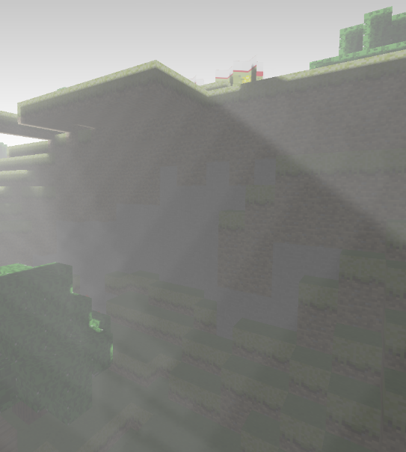I had thought that this issue would not happen due to the fragment shader in the final fog application step being able to interpolate between different layers, but that did not appear to be the case. The reason that I think that exponential depth distribution would have solved this issue, is that by grouping the front-most layers closer to each other, it would make the **interpolation** less obvious.

Figure : Visual layer artifacts at shadow borders close to the near plane of the frustum.

A final thing that could be significantly improved is the shadowing technique that is used by the fog. In my implementation I used cascaded shadow mapping since it was already available to me. However, the paper suggested exponential shadow mapping since it is supposedly much cheaper, and its inherent issues are of no concern when used for volumetric fog.

# Problems Encountered in Development

The only real issue that was encountered in development was related to the implementation of exponential depth distribution, something which was mentioned a lot of times throughout the paper but never actually explained. An attempt was made at implementing exponential depth distribution by re-using the same function used to distribute the cascades in the cascading shadow map technique but did not give the expected results.

# Conclusions of the project

Volumetric fog as proposed by the paper is indeed a much more immersive alternative to simple depth-based attenuation and has been technologically feasible since mid-2013 when *Assassin’s Creed IV*: *Black Flag* originally implemented this technique. It allows for a lot of artistic modification through the use of noise and other variables, which allows volumetric fog to be used to represent a wide array of atmospheric effects, such as morning mist to sandstorms.

However, volumetric fog is quite demanding on consumer hardware when not implemented and optimized properly. This is not helped by the fact that the original paper does not really talk about ways in which to optimize the process of generating the intermediate textures (density, in-scattering and accumulation).

# Bibliography

Bartlomiej, Wronski. “Volumetric Fog and Lighting.” GPU Pro 6, 2015, pp. 217–242.,